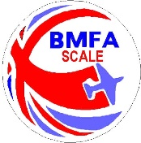 | Free Flight Open / Flying Only Record  (2023)
Event/ Date
……………………………..
Name | BMFA | Model | Kit, Plan, O/D | Static | Best Flight | Total | Place

